DEEP LEARNING & NEURAL NETWORKS
TOP 15 MUST-PREPARE QUESTIONS 🔥 TOP 15 MUST-PREPARE QUESTIONS
- • What is a Neural Network?
- • What is Backpropagation?
- • What is Gradient Descent?
- • Bias vs Variance
- • Overfitting vs Underfitting
- • What is Regularization?
- • CNN vs ANN vs DNN
- • RNN vs LSTM vs GRU
- • What is Attention Mechanism?
- • What is Transformer?
- • BERT vs GPT
- • Transfer Learning
- • GAN vs VAE
- • Q-Learning vs DQN
- • ROC–AUC and when to use it

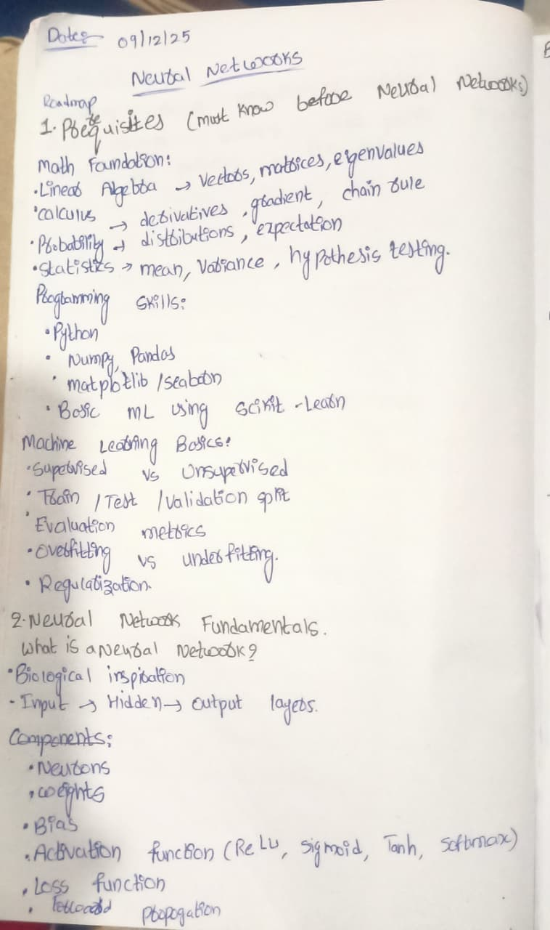
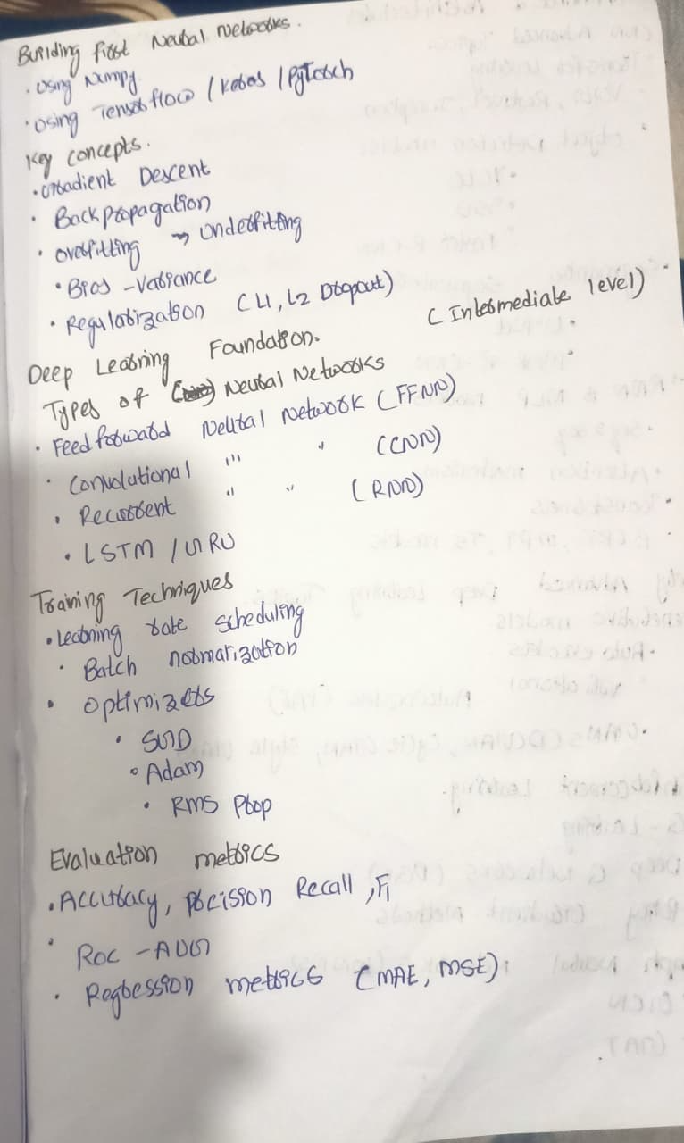
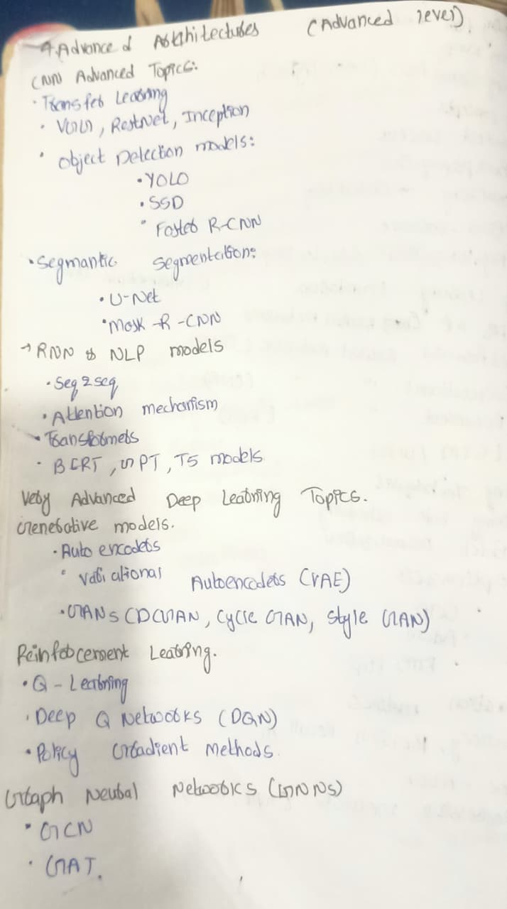
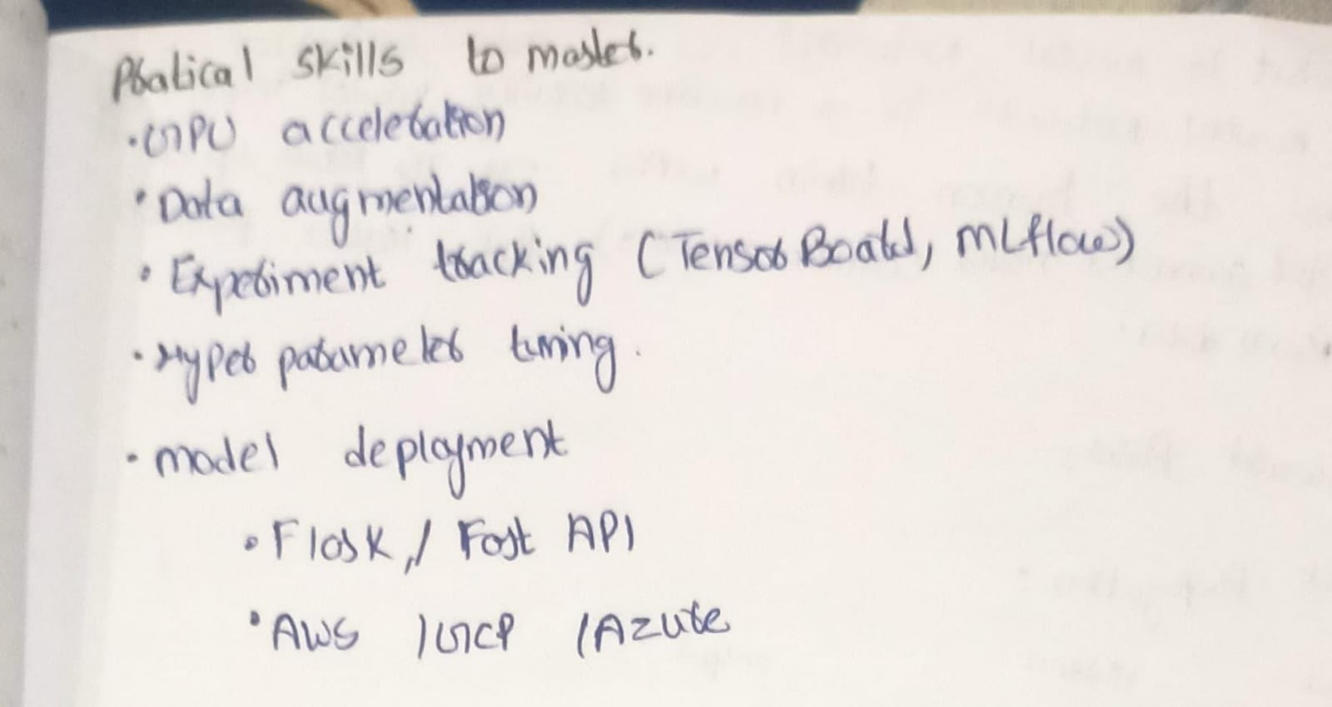1. What is a neural network?
A Neural Network is a machine learning model inspired by the human brain. It consists of inter connected nodes called neurons , that work together to learns patterns and relationships from data.
2. What is a Neuron?
* It receives input values, applies weights and a bias, processes them using an activation function, and produces an output.
* A neuron is like a small calculator that decides how important an input is and passes the result to the next layer.
How a Neuron Works (Step-by-Step)
- Input (x) – receives data
- Weights (w) – decide importance of each input
- Weighted Sum – multiplies inputs with weights and adds bias
- Activation Function – decides whether to pass the signal forward
- Output – sent to the next neuron or final layer
3. What is a weight?
A weight represents the importance of an input feature in a neuron.
Higher weight means the input has more influence on the output.
4. What is bias?
Bias is an additional constant added to the weighted sum.
It helps the model shift the activation function and learn better patterns.
5. What is an activation function?
An activation function decides whether a neuron should be activated or not.
It introduces non-linearity into the model, allowing neural networks to learn complex patterns.
Examples of activation functions (name only is enough)
- ReLU
- Sigmoid
- Tanh
- Softmax
6. What is ReLU?
ReLU stands for Rectified Linear Unit.
It outputs zero for negative inputs and the same value for positive inputs.
7. What is Forward Propagation?
Forward propagation is the process in a neural network where input data is passed from the input layer through hidden layers to the output layer to generate a prediction.
8. What is backpropagation?
Backpropagation is a training algorithm used to update weights and bias.
It calculates the error and propagates it backward to minimize loss.
9. What is loss function?
A loss function measures how far the predicted output is from the actual value.
10. What is Gradient Descent?
Gradient Descent is an optimization algorithm used to minimize the loss (error) of a machine learning or deep learning model.
11.What is Bias and Variance?
Bias and Variance are two types of errors that explain why a model performs poorly.
- Bias → error due to wrong assumptions
- Variance → error due to too much sensitivity to data
12 What is Regularization?
Regularization is a technique used to reduce overfitting by penalizing large model weights.
* Regularization is a technique used to prevent overfitting by adding a penalty term to the loss function that discourages large model weights, helping the model generalize better.
13. What is Deep Learning?
* Deep learning is a subset of machine learning that uses neural networks with multiple hidden layers to learn complex patterns from large amounts of data.
* Deep learning uses multi-layer neural networks to solve complex problems like image, speech, and text understanding.
14. What are TensorFlow, Keras, and PyTorch?
They are Deep Learning frameworks — tools that help you build, train, and deploy neural networks easily without writing math from scratch.
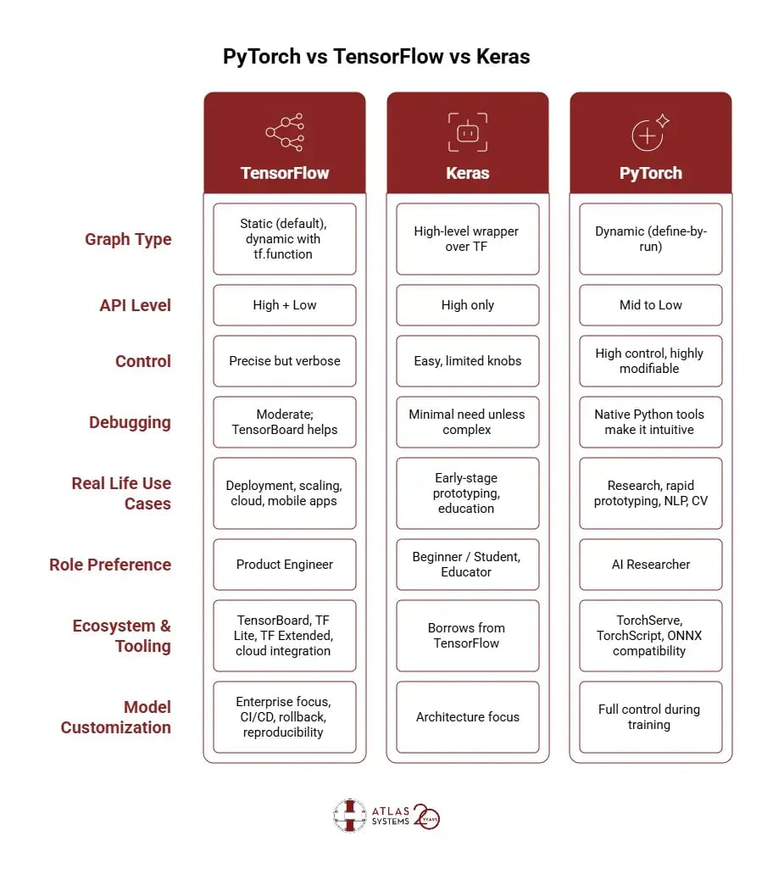
TensorFlow
📌 What is TensorFlow?
TensorFlow is a powerful deep learning framework developed by Google.
It is used to:
- Build large-scale deep learning models
- Deploy models to production (mobile, web, cloud)
- Train models efficiently on GPUs/TPUs
🧠 Key Features
- Uses tensors (multi-dimensional arrays)
- Supports static & optimized computation graphs
- Strong for production & deployment
- Scales well for big data
📦 Common Uses
- Image recognition
- NLP
- Recommendation systems
- Large AI products

🟢 Keras
📌 What is Keras?
Keras is a high-level deep learning API that runs on top of TensorFlow.
👉 Think of it as:
User-friendly interface for TensorFlow
🧠 Key Features
- Very easy to learn
- Less code, very readable
- Best for beginners
- Fast prototyping
📦 Common Uses
- Learning deep learning
- Academic projects
- Fast experiments
🔴 PyTorch
📌 What is PyTorch?
PyTorch is a deep learning framework developed by Facebook (Meta).
It is known for:
- Flexibility
- Dynamic computation graphs
- Research-friendly design
🧠 Key Features
- Pythonic & intuitive
- Easy debugging
- Dynamic graphs (define model on the fly)
- Preferred in research & startups
*TensorFlow is a deep learning framework for building and deploying models, Keras is a high-level API that simplifies TensorFlow usage, and PyTorch is a flexible deep learning framework popular for research and dynamic model building.
15.what are the Types of Neural Networks?
1.Feedforward Neural Network (ANN / FNN)
2.Deep Neural Network (DNN)
3.Convolutional Neural Network (CNN)
4.Recurrent Neural Network (RNN)
5.Long Short-Term Memory Network (LSTM)
6. Gated Recurrent Unit (GRU)
7.Autoencoder
8.Variational Autoencoder (VAE)
9.Generative Adversarial Network (GAN)
10.Radial Basis Function Network (RBFN)
11.Self-Organizing Map (SOM)
12.Hopfield Network
13.Boltzmann Machine
14.Restricted Boltzmann Machine (RBM)
15.Transformer Neural Network
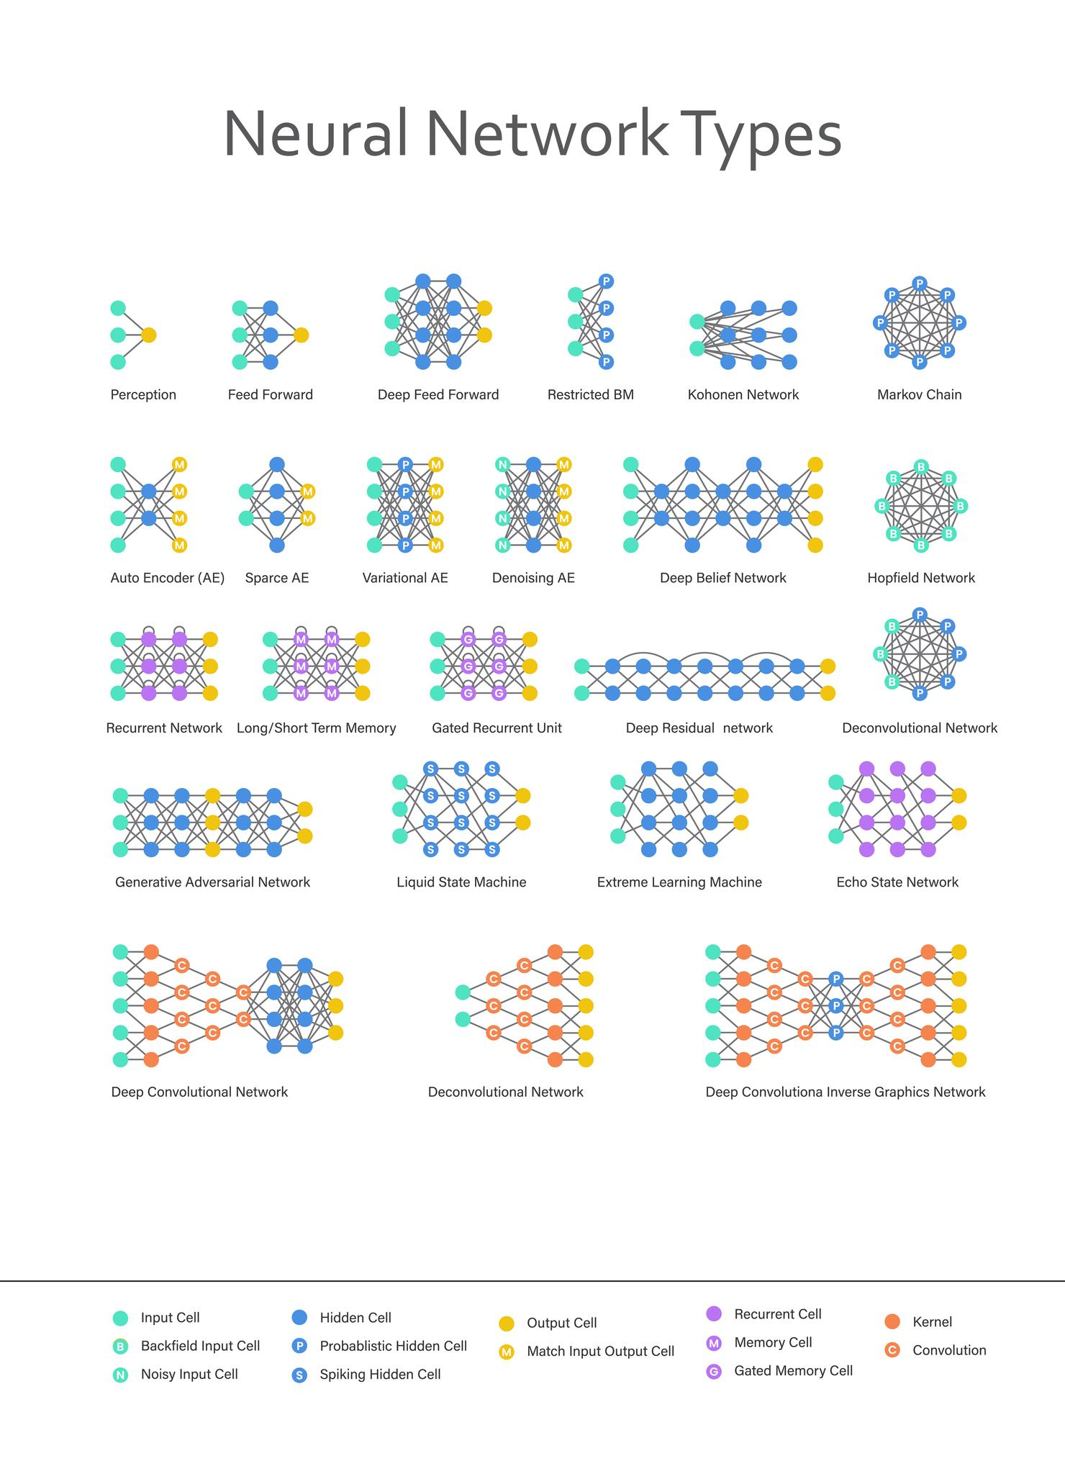
16.What is FNN? (Interview Definition)
Feedforward Neural Network (FNN) is a type of neural network in which information flows only in one direction, from the input layer → hidden layer(s) → output layer, without any loops or feedback connections.
🔹 Examples of FNN (Use-Cases)
- Customer Churn Prediction
- House Price Prediction
- Credit Risk / Loan Approval
- Email Spam Classification
- Student Performance Prediction
- Sales Forecasting (tabular data)
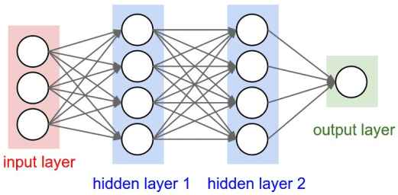

17. What is DNN (Deep Neural Network)?
Deep Neural Network (DNN) is a neural network that has multiple hidden layers between the input and output layers.
Because it’s “deep,” it can learn complex patterns and representations from data.
🔹 Where DNNs are used
- Customer churn & credit risk (tabular data)
- Speech recognition
- Recommendation systems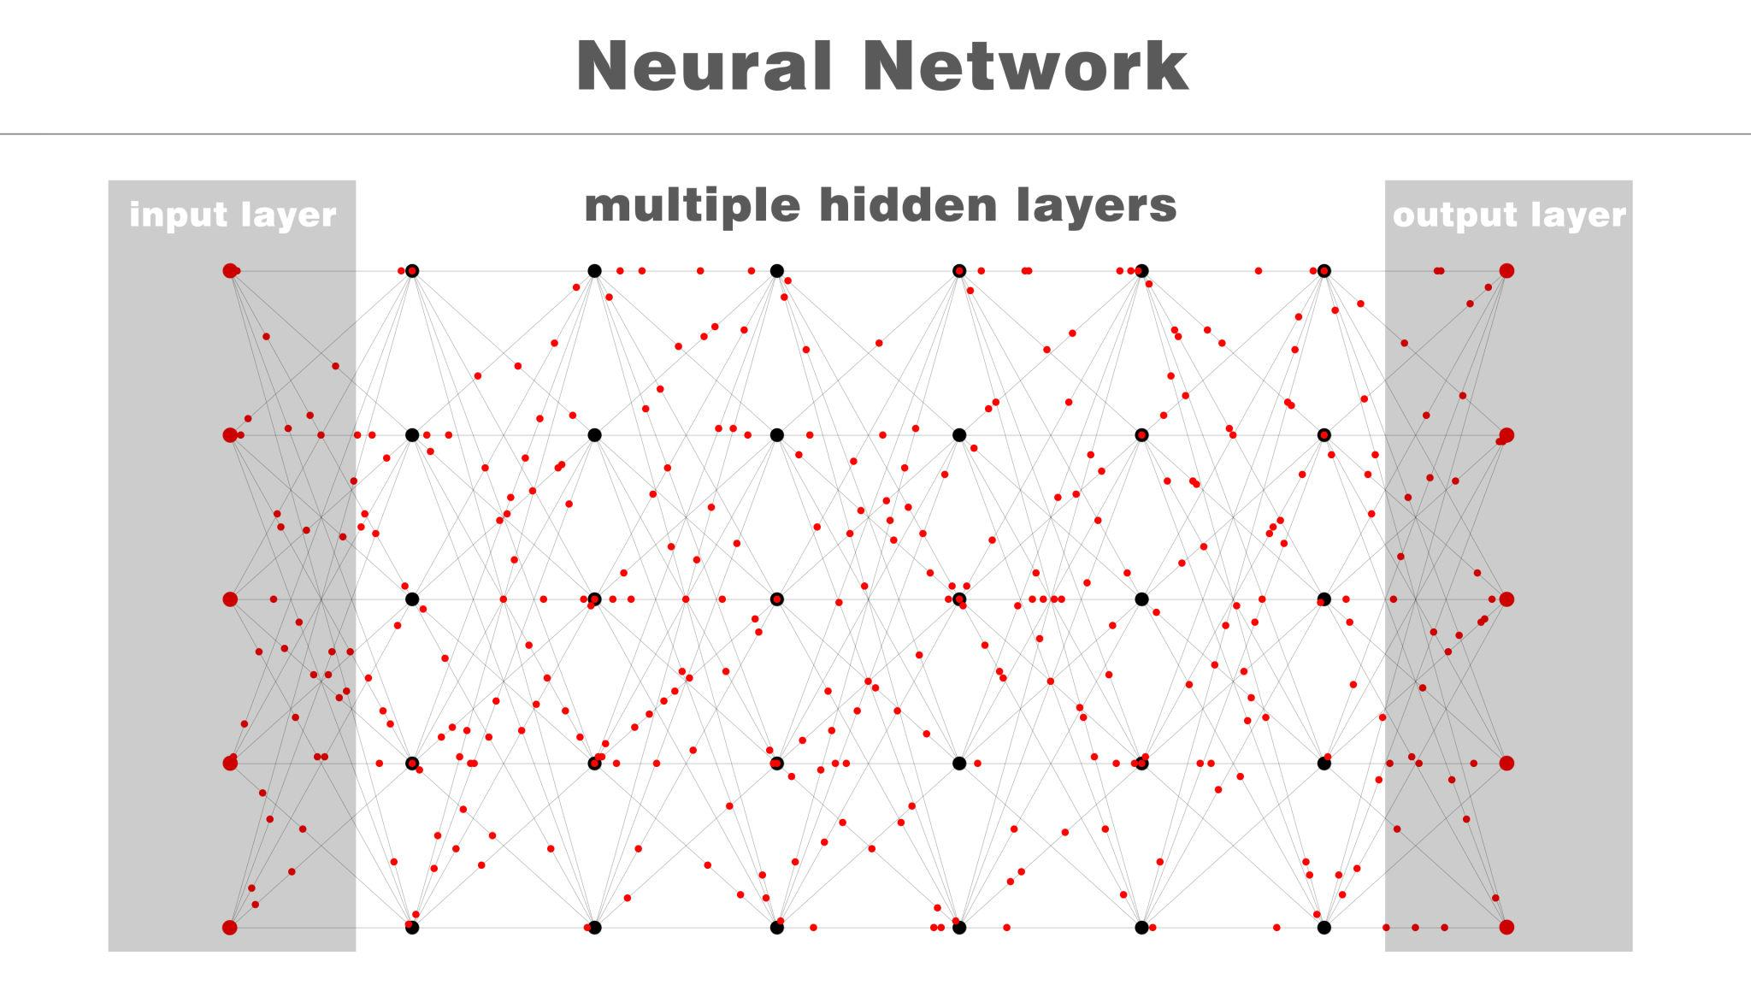
- Image/text tasks (as the base of CNNs/RNNs)
18. What is CNN (Convolutional Neural Network)?
Convolutional Neural Network (CNN) is a type of deep neural network designed to automatically extract features from images and spatial data using convolution operations.
- A CNN is a deep learning model that uses convolution and pooling layers to learn spatial features from images and reduce dimensionality.
Where CNN is used
- Image classification
- Face recognition
- Medical image analysis
- Object detection (YOLO, SSD)
- Video processing
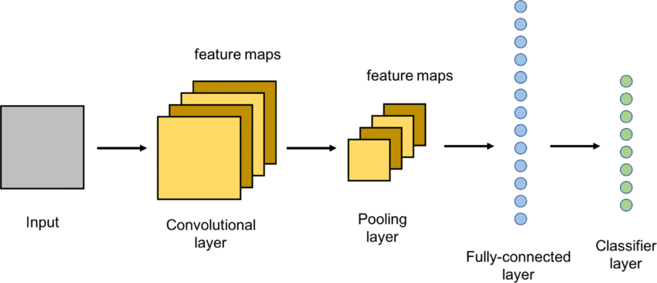
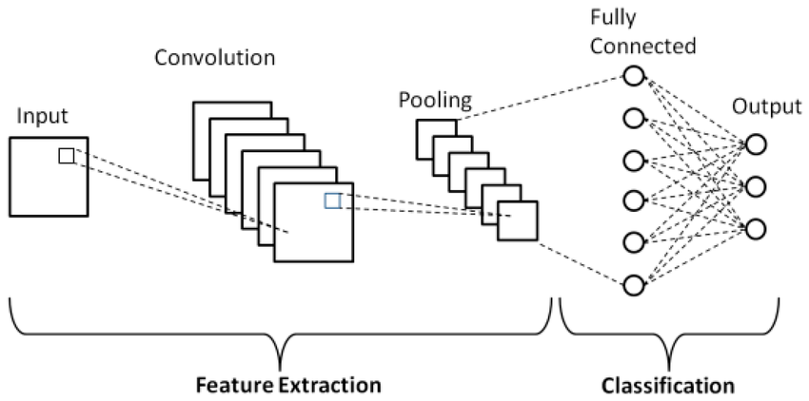
19. What is RNN (Recurrent Neural Network)?
Recurrent Neural Network (RNN) is a type of neural network designed to handle sequence data by using memory of previous inputs.
Unlike FNN/CNN, RNNs have loops, so information can persist across time steps.
Where RNNs are used
- Text & language modeling
- Sentiment analysis
- Speech recognition
- Time-series forecasting
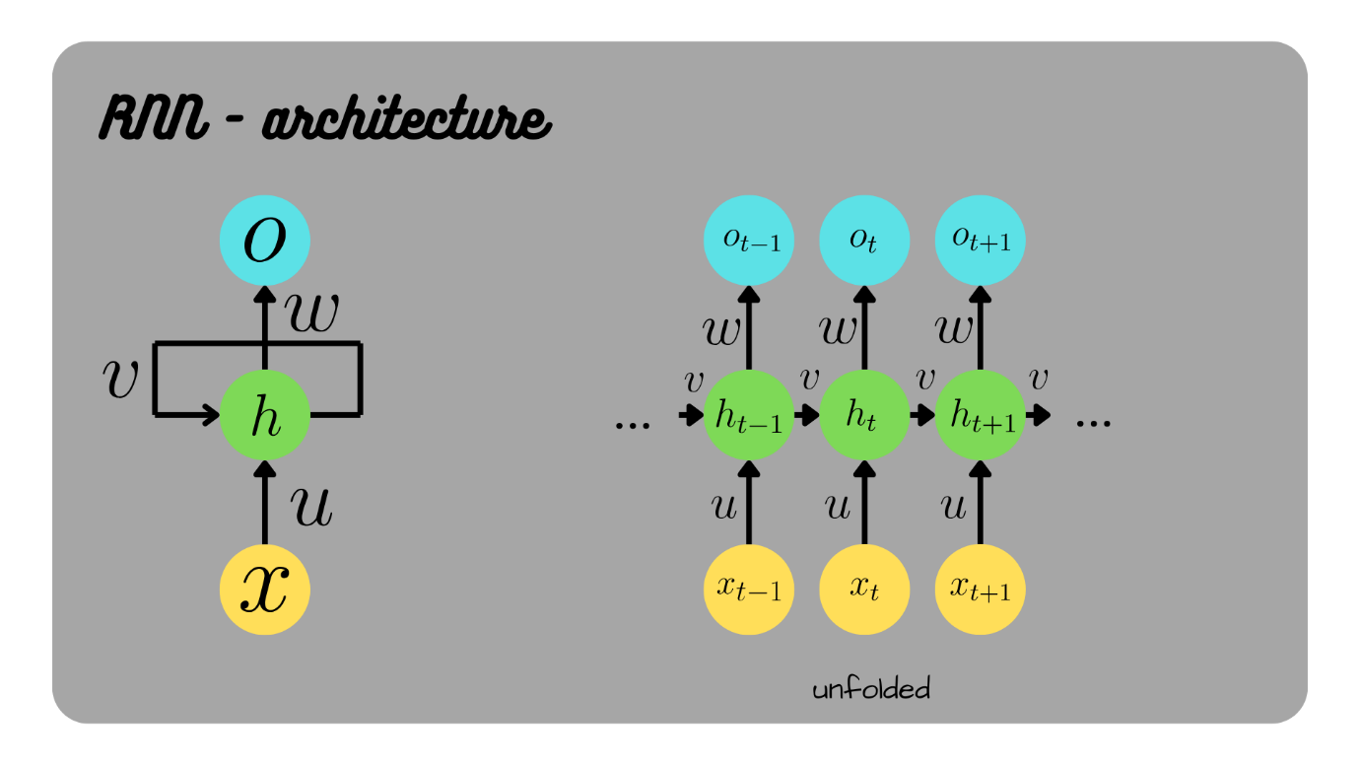
How to read this RNN image (quick guide)
- xₜ (Input at time t) → current word/value
- hₜ (Hidden state) → memory from previous step
- Loop arrow → shows memory feedback
- Unrolled view → same network repeated over time

20. What is LSTM (Long Short-Term Memory)?
LSTM (Long Short-Term Memory) is a type of Recurrent Neural Network (RNN) designed to learn long-term dependencies in sequence data by using a memory cell and gating mechanisms, which help overcome the vanishing gradient problem.
Examples / Use-Cases of LSTM
- Sentiment Analysis (reviews, tweets)
- Time-Series Forecasting (sales, stock prices)
- Speech Recognition
- Machine Translation
- Chatbots
- Weather prediction
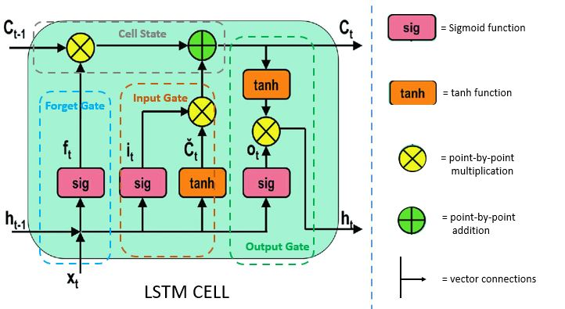
21. 🧠 What is GRU (Gated Recurrent Unit)?
RU (Gated Recurrent Unit) is a type of Recurrent Neural Network (RNN) that uses gating mechanisms to control the flow of information and capture long-term dependencies, but with a simpler structure than LSTM.
Examples / Use-Cases of GRU
- Sentiment Analysis
- Text classification
- Speech recognition
- Time-series forecasting
- Chatbots
- Sequence prediction tasks
📌 Preferred when:
- Dataset is smaller
- Faster training is required
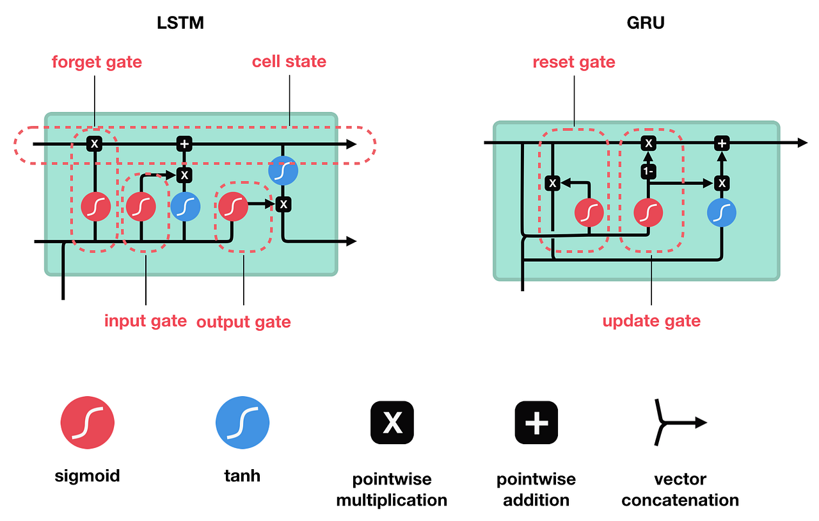
22. What are Training Techniques?
Training techniques are methods used during model training to improve learning speed, stability, and accuracy, and to reduce overfitting.
They control how a neural network learns, not what it learns.

1️⃣ Learning Rate Scheduling
Learning Rate Scheduling changes the learning rate during training instead of keeping it constant.
2️⃣ Batch Normalization
Batch Normalization normalizes layer inputs to have mean 0 and variance 1 during training.
3️⃣ Optimizers
An optimizer updates model weights to minimize the loss using gradients.
🔹 SGD (Stochastic Gradient Descent)
Idea: Update weights using gradients from small batches.
- SGD updates weights using gradients computed from mini-batches of data

🔹 Adam (⭐ Most Popular)
Idea: Combines Momentum + Adaptive learning rates.
Adam is an adaptive optimizer that combines momentum and RMSprop for fast and efficient training.
🔹 RMSprop
Idea: Adjusts learning rate based on recent gradients.
23. 📈 What is ROC–AUC?
ROC–AUC stands for Receiver Operating Characteristic – Area Under the Curve.
It measures how well a binary classification model can distinguish between positive and negative classes across all classification thresholds.
ROC Curve plots:
- X-axis: False Positive Rate (FPR) = FP / (FP + TN)
- Y-axis: True Positive Rate (TPR / Recall) = TP / (TP + FN)
Each point on the curve = a different decision threshold.

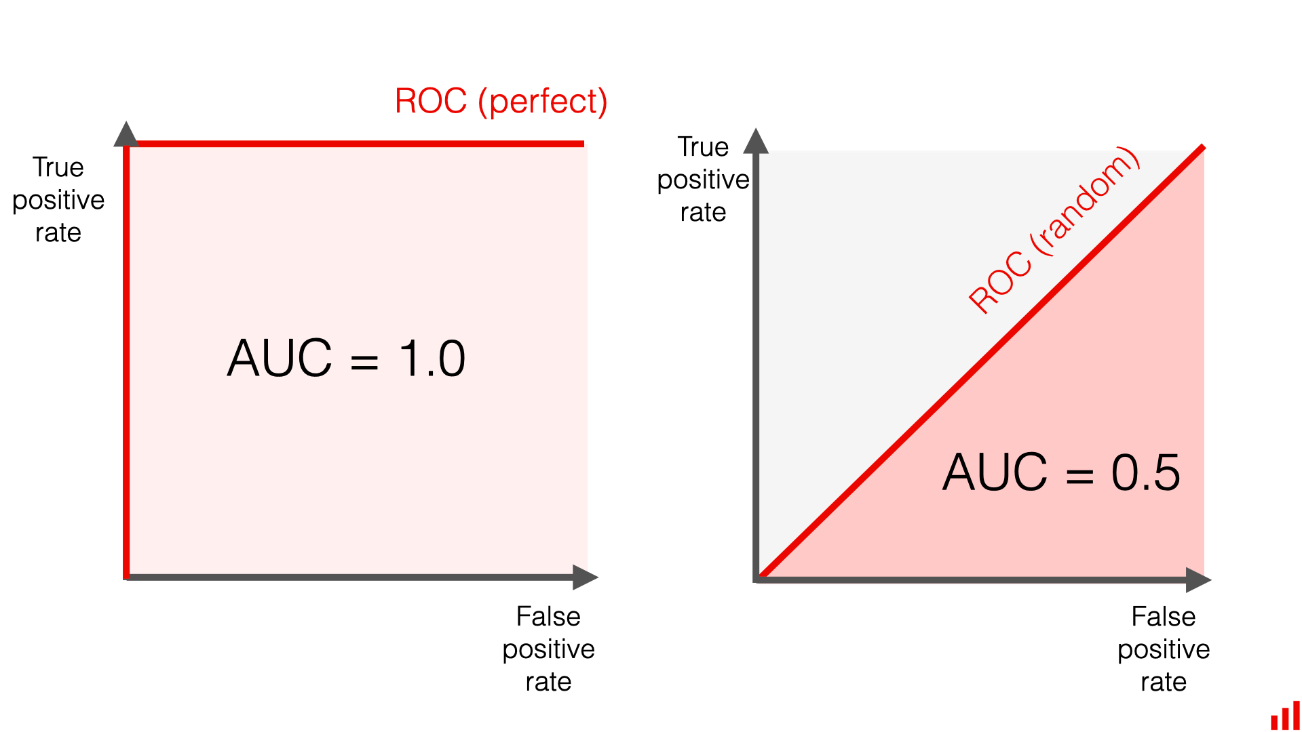

ADVANCED LEVEL
24. What is Architecture?
Architecture refers to the overall structure and design of a model, including how layers are arranged, how data flows, and how components are connected in a neural network.
What architecture includes
A neural network architecture defines:
- Number of layers (input, hidden, output)
- Type of layers (Dense, Convolution, Recurrent, Attention)
- Number of neurons per layer
- Activation functions
- Data flow direction
Advance Architectures
25.CNN Advanced Topics
- 🔁 Transfer Learning
Transfer Learning is a technique where a model pre-trained on a large dataset (like ImageNet) is reused for a new but related task.
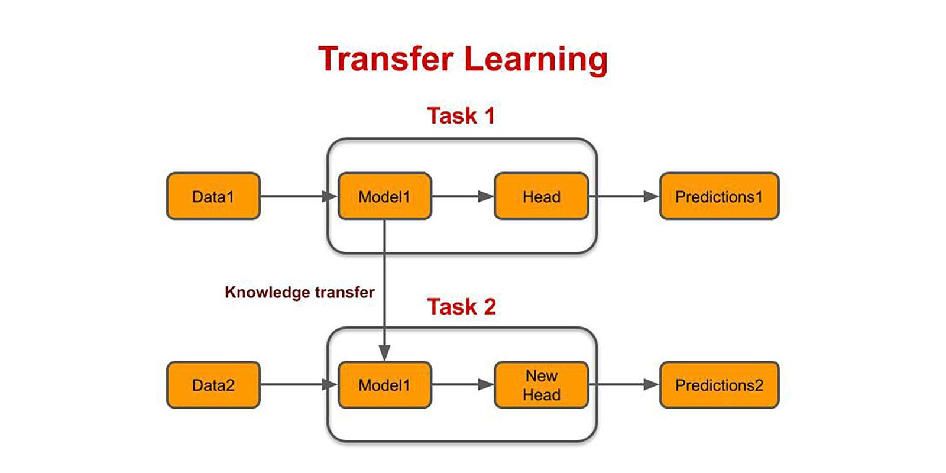

🧠 Pre-trained CNN Models
🔹 VGG (VGG16 / VGG19)
- Deep but simple stacked layers
- Uses only 3×3 convolutions
- High accuracy, very large model
Use: Image classification, transfer learning basics
🔹 ResNet (Residual Network)
- Uses skip / shortcut connections
- Solves vanishing gradient problem
- Can train very deep networks
Use: Industry standard, strong performance
🔹 Inception (GoogLeNet)
- Multiple filter sizes in parallel
- Captures multi-scale features
- Computationally efficient

🎯 Object Detection Models
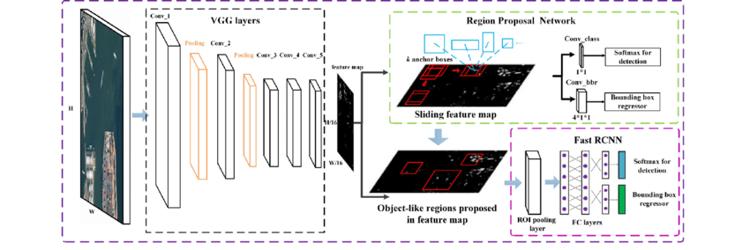

🔹 YOLO (You Only Look Once)
- Single-stage detector
- Very fast (real-time)
- Predicts bounding boxes + classes in one pass
Use: Real-time detection (traffic, CCTV)
🔹 SSD (Single Shot Detector)
- Single-stage detector
- Faster than R-CNN, slower than YOLO
- Good balance of speed & accuracy
Use: Mobile & embedded vision
🔹 Fast R-CNN
- Two-stage detector
- Region proposals → classification
- More accurate, slower than YOLO/SSD
Use: High-accuracy detection tasks
🧩 Semantic & Instance Segmentation
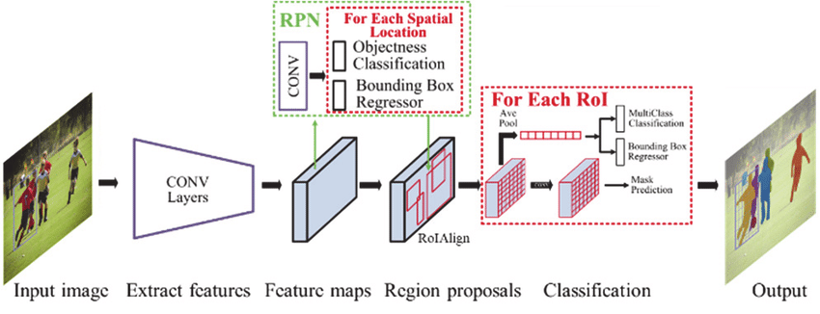
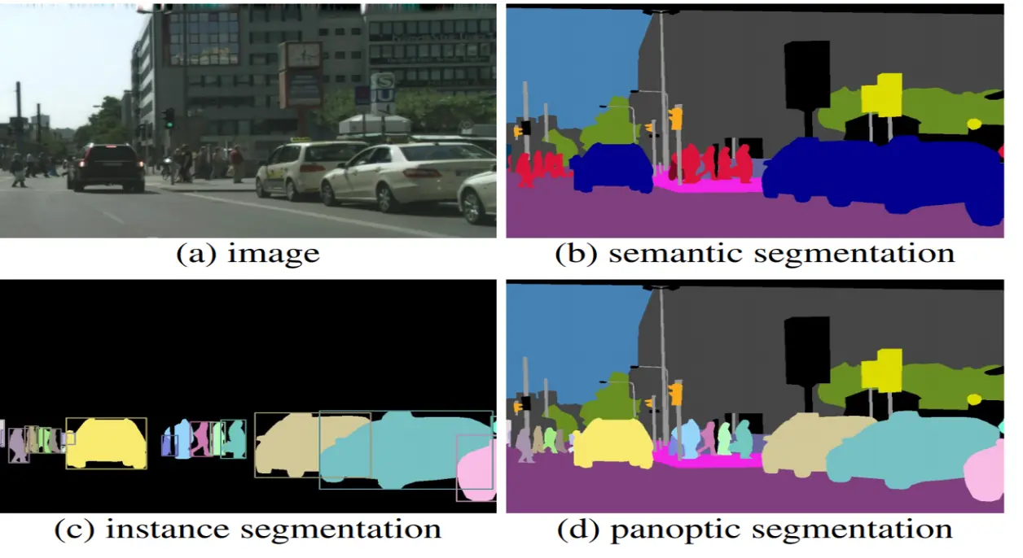
🔹 U-Net (Semantic Segmentation)
- Encoder–Decoder structure
- Pixel-wise classification
- Excellent for medical imaging
Output: Each pixel → class label
Mask R-CNN (Instance Segmentation)
- Extends Faster R-CNN
- Predicts:
  - Object class
  - Bounding box
  - Pixel-level mask per object
Output: Separate mask for each object
26. 🧠 RNN & NLP Models (Advanced)
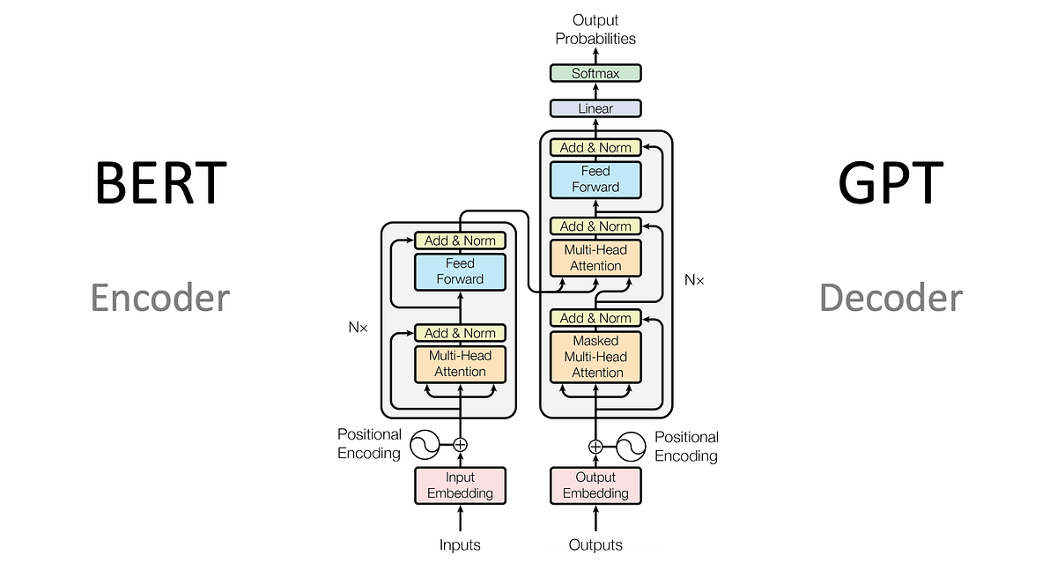

1️⃣ Seq2Seq (Sequence-to-Sequence Model)
A Seq2Seq model maps an input sequence to an output sequence of different length using:
- Encoder
- Decoder
Usually built using RNN / LSTM / GRU.
🔹 Example
- Machine Translation
  - Input: English sentence
  - Output: French sentence
- Text summarization
- Chatbots

2️⃣ Attention Mechanism ⭐
Attention allows the model to focus on important words in the input while generating each output token.
👉 Instead of remembering everything, the model looks back at relevant parts.
🔹 Why it’s important
- Solves long-sequence problem
- Improves translation & summarization
- Foundation of Transformers

🔹 Example
While translating:
“The cat sat on the mat”
The model focuses on “cat” when generating its translated word.
3️⃣ Transformers 🔥
🔹 What it is
A Transformer is a deep learning architecture that:
- Uses self-attention
- Removes recurrence (no RNNs)
- Enables parallel processing
🔹 Core blocks
- Self-Attention
- Multi-Head Attention
- Feed-Forward Network
- Positional Encoding
🔹 Why Transformers are powerful
- Faster training
- Handles long-range dependencies
- Backbone of modern NLP & GenAI

4️⃣ BERT (Encoder-based Transformer)
🔹 What it is
BERT = Bidirectional Encoder Representations from Transformers
- Reads text from both left & right
- Uses only encoder part of transformer
🔹 Best for
- Text classification
- Sentiment analysis
- Question answering
- Named Entity Recognition (NER)

🔹 Key idea
Bidirectional context understanding
5️⃣ GPT (Decoder-based Transformer)
🔹 What it is
GPT = Generative Pre-trained Transformer
- Uses only decoder
- Predicts next word
- Unidirectional (left → right)
🔹 Best for
- Text generation
- Chatbots
- Code generation
- Story writing
🔹 Key idea
Autoregressive text generation
6️⃣ T5 Model (Text-to-Text Transformer)
(You wrote TS MODEL, commonly asked as T5)
🔹 What it is
T5 (Text-To-Text Transfer Transformer) converts every NLP task into a text-to-text format.
🔹 Examples
- Translation
  - Input: "translate English to French: Hello"
  - Output: "Bonjour"
- Summarization
- Q&A
- Classification
🔹 Advantage
One model → many NLP tasks
27. 🧠 Generative Models (Overview)?
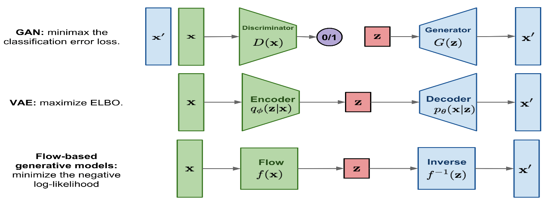

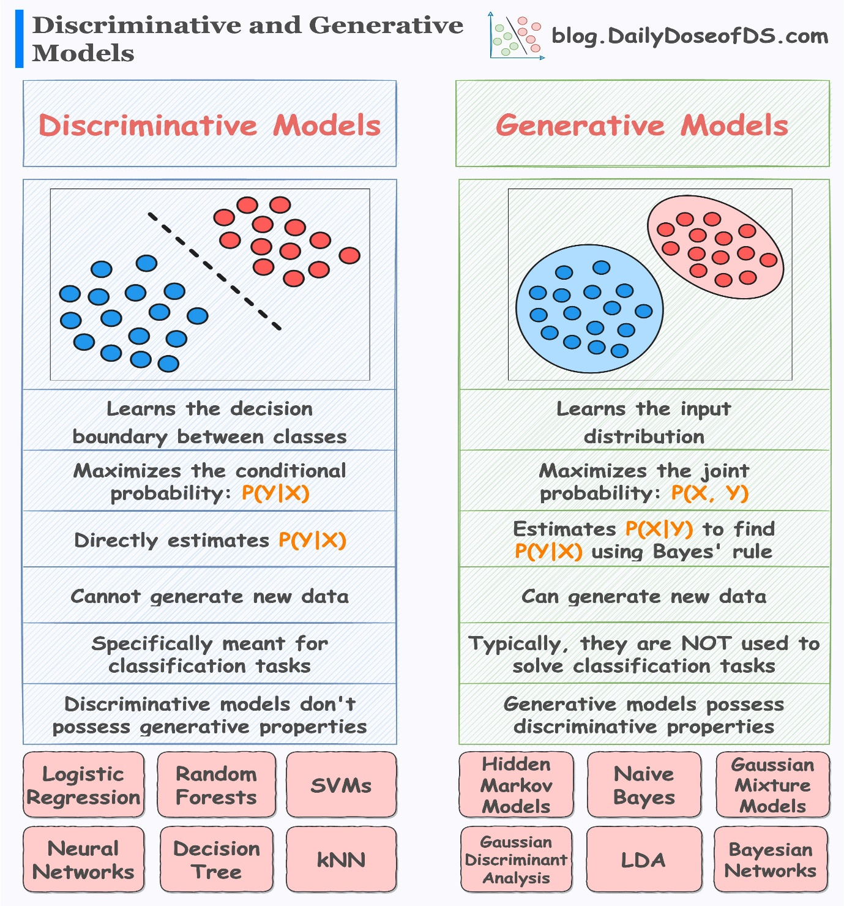
Generative models learn the underlying data distribution and can generate new, realistic data similar to the training data.
1️⃣ Autoencoders (AE) 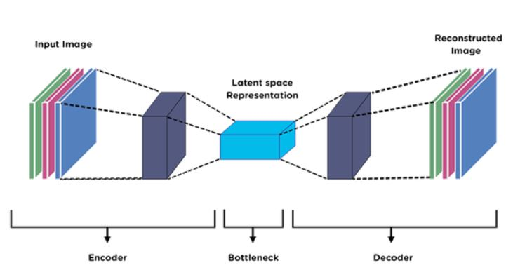
An Autoencoder is a neural network that learns to compress data (encode) and then reconstruct it (decode).
🔹 Structure
Input → Encoder → Latent space → Decoder → Output
🔹 Use cases
- Dimensionality reduction
- Anomaly detection
- Image denoising

2️⃣ Variational Autoencoder (VAE)
A VAE is a probabilistic autoencoder that learns a continuous latent space, enabling data generation.
🔹 Key idea
- Learns mean (μ) and variance (σ)
- Samples from a probability distribution
3️⃣ GAN (Generative Adversarial Network)
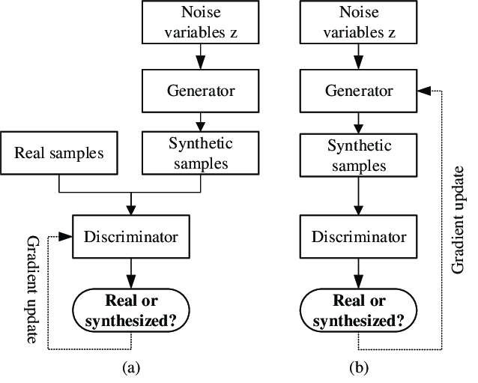
A GAN consists of two competing networks:
- Generator → creates fake data
- Discriminator → detects real vs fake data
They train in a min–max game.
🔹 Use cases
- Image generation
- Deepfakes
- Style transfer

4️⃣ Conditional GAN (cGAN)
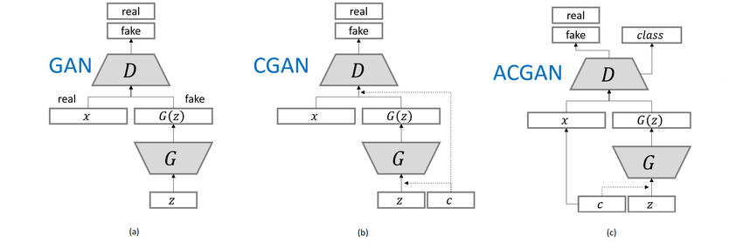
A cGAN generates data conditioned on labels or attributes.
🔹 Example
- Generate digits conditioned on number (0–9)
- Generate faces with specific attributes
📌 Output is controlled generation.
5️⃣ CycleGAN
A CycleGAN performs image-to-image translation without paired data.
🔹 Example
- Horse ↔ Zebra
- Summer ↔ Winter
- Photo ↔ Painting
🔹 Key concept
Cycle consistency loss ensures meaningful mapping.
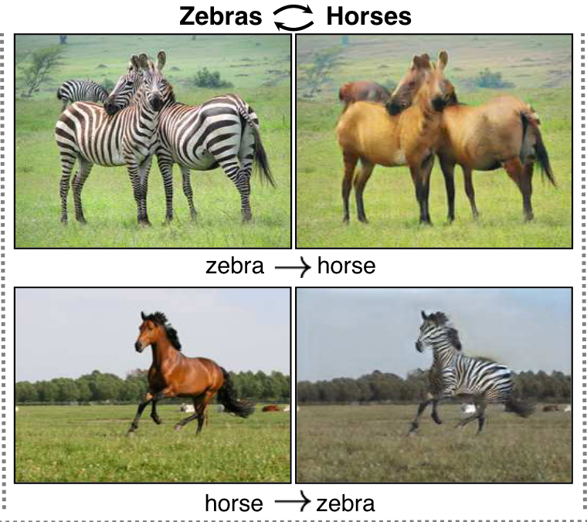

6️⃣ StyleGAN
🔹 What it is
StyleGAN is an advanced GAN that controls image style at different levels.
🔹 Why it’s special
- Separate control of:
  - Pose
  - Face shape
  - Texture
- Generates high-resolution, photorealistic images
🔹 Use cases
- Face generation
- Art & creative AI
- Game & media industry
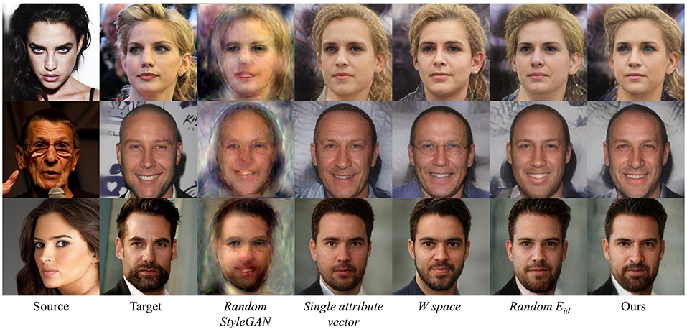
⚖️ Quick Comparison Table
Model | Generative? | Key Feature | Example Use
Autoencoder | ❌ | Compression | Anomaly detection
VAE | ✅ | Probabilistic latent space | Image generation
GAN | ✅ | Adversarial training | Realistic images
cGAN | ✅ | Conditional output | Controlled generation
CycleGAN | ✅ | Unpaired translation | Style transfer
StyleGAN | ✅ | Style control | Face synthesis

28. 🤖 What is Reinforcement Learning (RL)?
Reinforcement Learning is a type of machine learning where an agent learns by interacting with an environment and improves its behavior by receiving rewards or penalties.
👉 Goal: maximize cumulative reward.
Core components
- Agent – learner/decision maker
- Environment – where agent operates
- State (S) – current situation
- Action (A) – choice made by agent
- Reward (R) – feedback from environment
- Policy (π) – strategy to choose actions

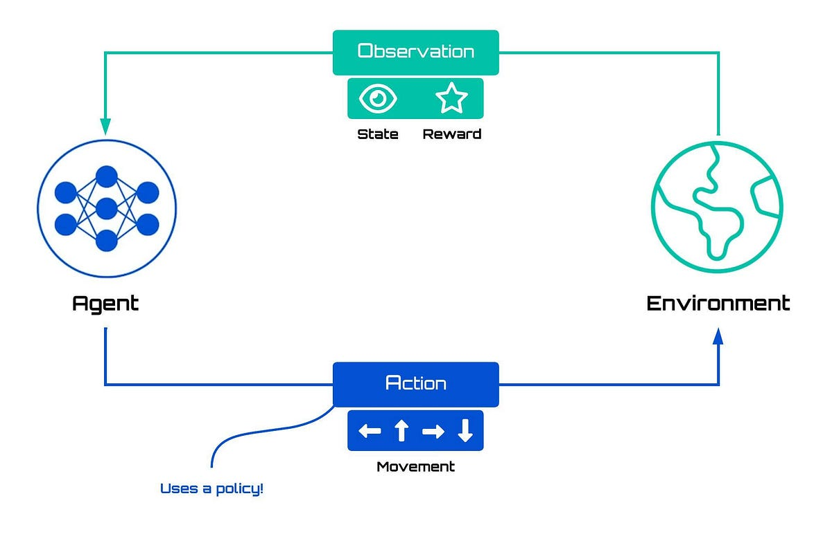
29. 🔹 What is Q-Learning?
Q-Learning is a model-free, value-based RL algorithm that learns the quality (Q-value) of taking an action in a given state.
🔹 Q-value
$$Q(s,a)=\text{expected future reward for action }a\text{ in state }s$$
🔹 Update rule
$$Q(s,a)←Q(s,a)+α[r+γmax⁡Q(s^{'},a^{'})-Q(s,a)]$$
- α → learning rate
- γ → discount factor
🔹 Example
- Grid-world navigation
- Simple games (maze, path finding)
📌 Limitation: Q-table explodes for large state spaces
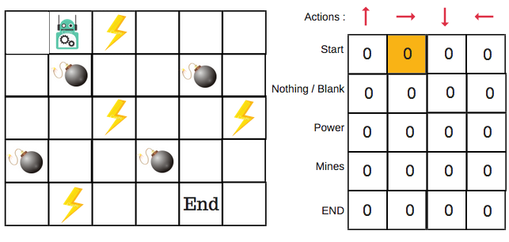
30. What is Deep Q-Network (DQN)?
DQN uses a deep neural network instead of a Q-table to approximate Q-values.
👉 Q-table ❌ → Neural Network ✅
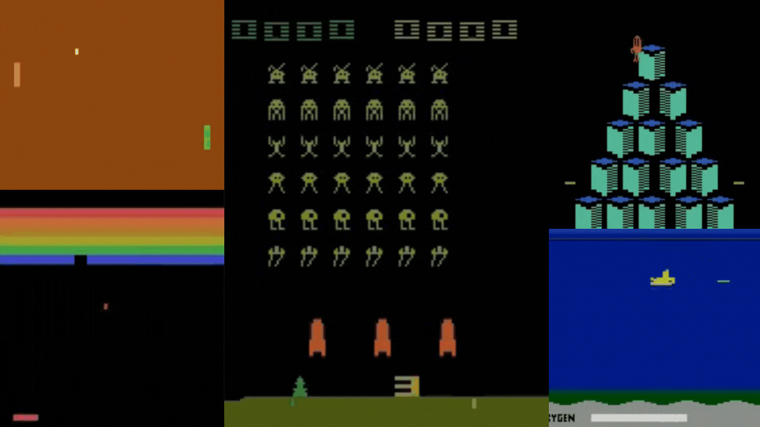
🔹 Why DQN is needed
- Handles high-dimensional states (images, video)
- Scales Q-Learning using deep learning
🔹 Key techniques
- Experience Replay – store & reuse past experiences
- Target Network – stabilizes training
🔹 Example
- Playing Atari games
- Robotics control
- Autonomous navigation
31. Policy Gradient Methods?
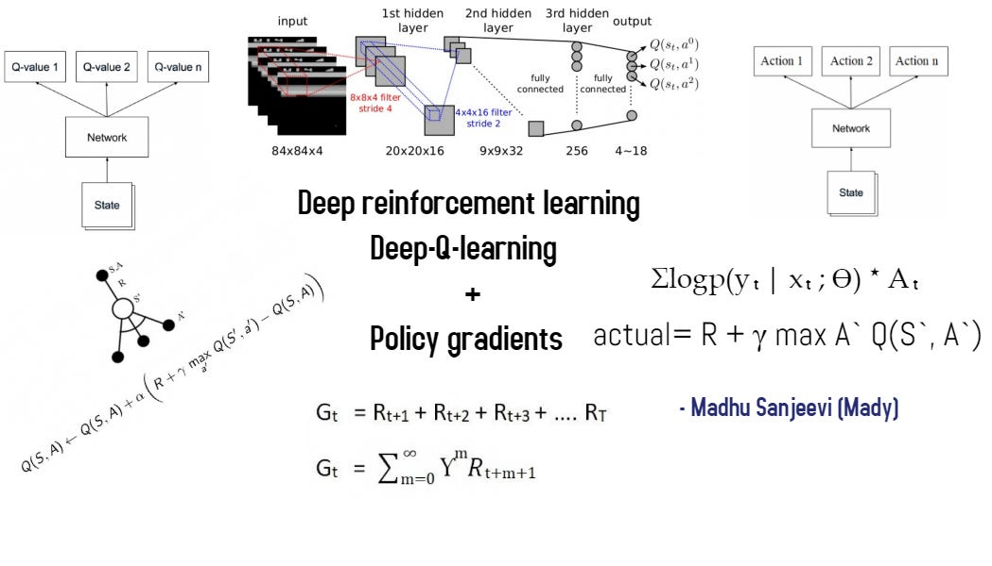
Instead of learning Q-values, these methods directly learn the policy (probability of actions).
👉 Learn:
$$π(a∣s)=P(\text{action }a∣\text{state }s)$$Why Policy Gradient?
- Works with continuous action spaces
- More stable for complex tasks
- Avoids Q-value estimation

🔹 Examples of Policy Gradient
- REINFORCE
- Actor–Critic
- A2C / A3C
- PPO (very popular)
32.What is 🧠 Graph Neural Networks (GNNs)?
Graph Neural Networks (GNNs) are neural networks designed to learn from graph-structured data, where information is represented as nodes (entities) and edges (relationships).
👉 They learn by passing and aggregating messages between connected nodes.
How GNNs work (simple)
- Message Passing: each node collects info from neighbors
- Aggregation: combine neighbor messages (sum/mean/max/attention)
- Update: update node embedding with a neural layer
- Repeat for K layers → info from K-hop neighbors
Common GNN Types
- GCN (Graph Convolutional Network) – convolution on graphs
- GraphSAGE – samples neighbors (scales to large graphs)
- GAT (Graph Attention Network) – attention over neighbors
- GIN (Graph Isomorphism Network) – strong theoretical power
33.What is ⚡ GPU Acceleration?
GPU acceleration uses a Graphics Processing Unit to speed up model training and inference by performing massively parallel computations.
🔹 Why GPUs are faster than CPUs
- Thousands of cores → parallel math
- Optimized for matrix/tensor operations
- Ideal for deep learning workloads
34. 🖼️ Data Augmentation?
Data augmentation artificially increases dataset size by applying transformations to existing data without changing labels.
🔹 Why it’s needed
- Reduces overfitting
- Improves generalization
- Helps when data is limited
🔹 Common augmentation techniques (Images)
- Rotation
- Flipping (horizontal/vertical)
- Scaling / Cropping
- Brightness / Contrast
- Noise addition
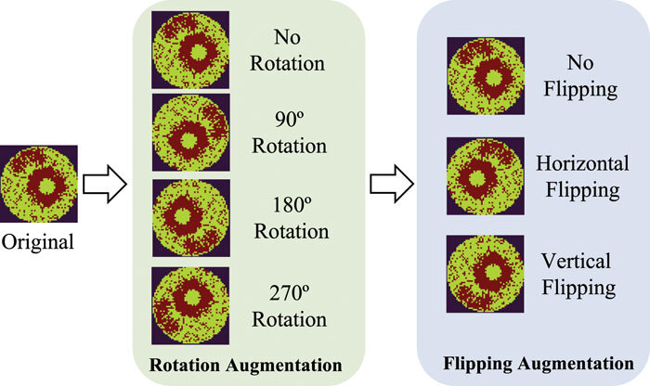
35. 📈 What is Forecasting?
Forecasting is the process of predicting future values based on historical data patterns, trends, and seasonality.
Using past data to estimate future outcomes.
Example:
- Predict next month’s sales using last 3 years of sales data.
Key components of forecasting
- Trend – long-term increase or decrease
- Seasonality – repeating patterns (daily, monthly, yearly)
- Cyclic patterns – irregular long-term cycles
- Noise – random variation

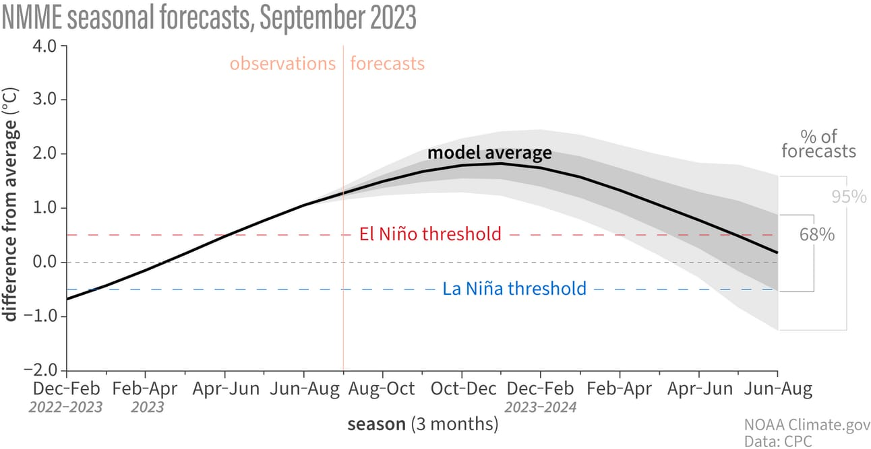
Types of forecasting
- Short-term – hours, days (weather, traffic)
- Medium-term – weeks, months (sales, demand)
- Long-term – years (population, business planning)
Common forecasting methods
- Statistical: Moving Average, ARIMA
- Machine Learning: Linear Regression, Random Forest
- Deep Learning: LSTM, GRU, Transformers
Real-world examples
- Sales forecasting
- Stock price prediction
- Energy demand forecasting
- Weather forecasting
- Traffic prediction

